**CCL Assignment No. 1**

**Name**- Shashank Vijay Kapadnis

**Roll No.-** 33324

**Batch**- L11

**Contact No.-** 9665202078

**Email Id-** [shashankkapadnis@gmail.com](mailto:sayeebhoite7@gmail.com)

**ID card-**

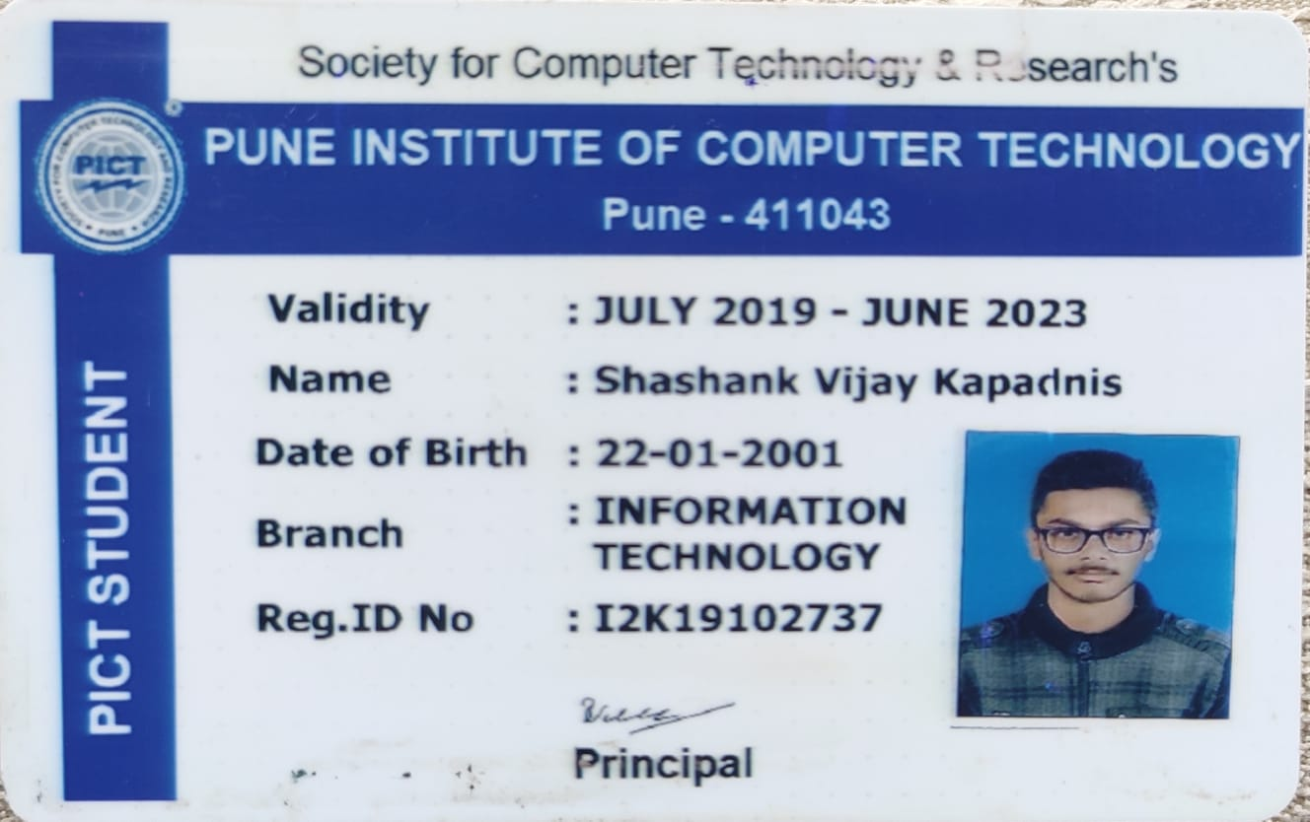

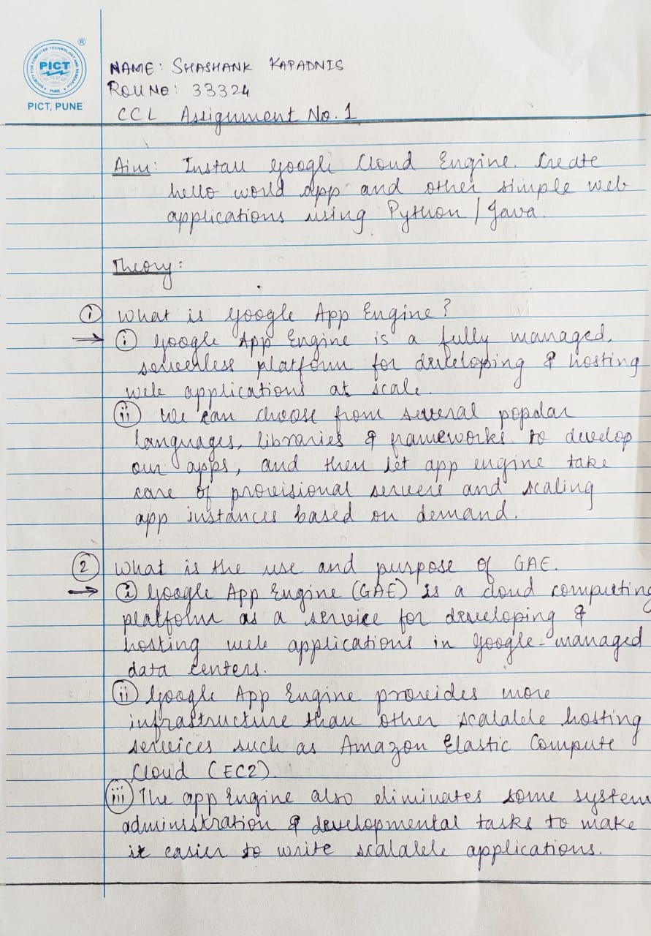

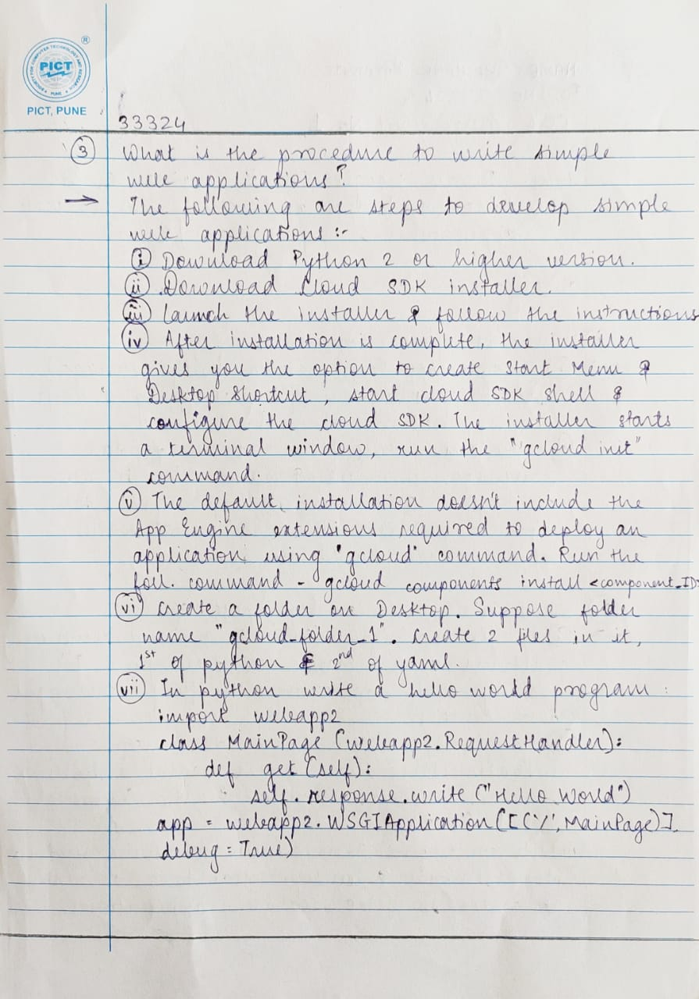

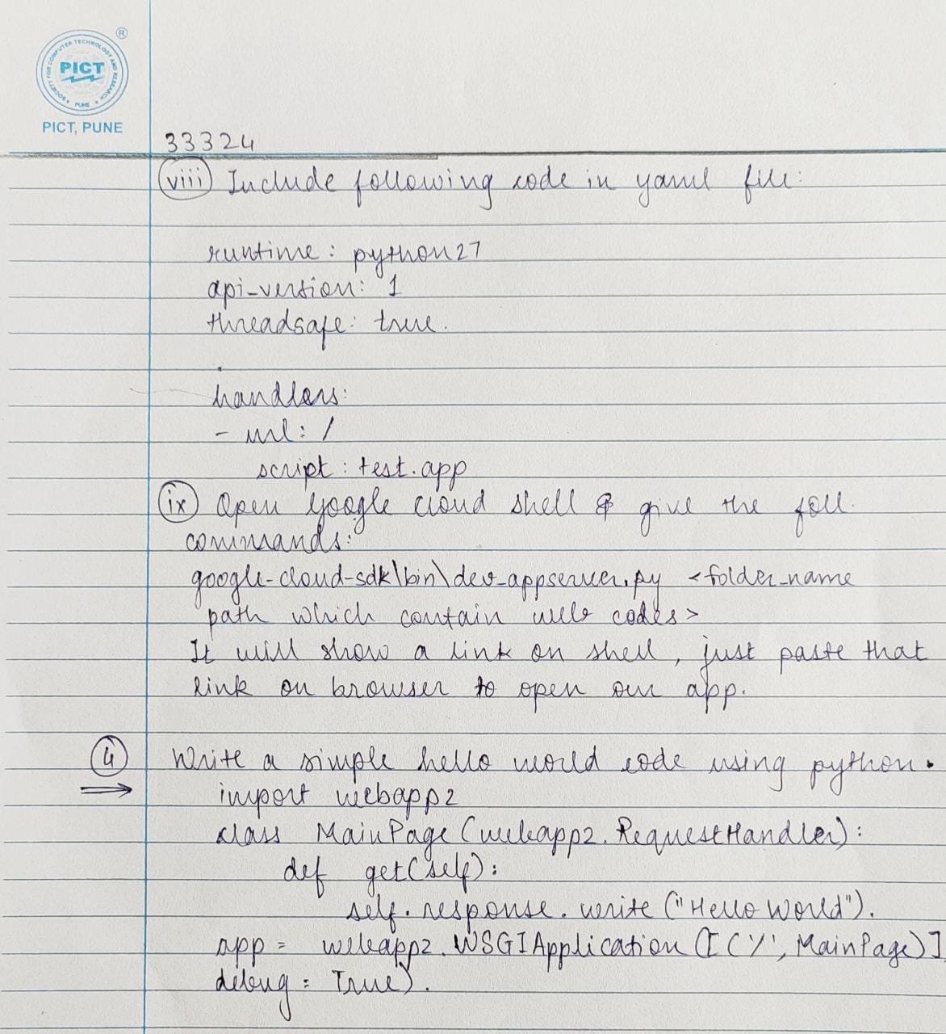

**Screenshots:**



